Microsoft logo

Complete Solution



This document is provided “as-is.” Information and views expressed in this document, including URL and other Internet Web site references, may change without notice. You bear the risk of  
using it. Some examples are fictitious and are for illustration only. No real association is intended  
or inferred. This document does not provide you with any legal rights to any intellectual property in any Microsoft product. You may copy and use this document for your internal reference purposes.

© 2023 Microsoft Corporation. All rights reserved.

## Prerequisites

Complete lab 01.

# Import solution

If you completed lab 06, skip to the next task.

1. Navigate to <https://powerautomate.microsoft.com> and select the correct environment.
2. Select **Solutions** and then select **Import solution**.

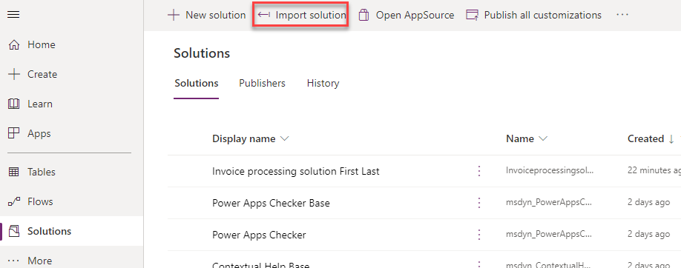

1. Select **Browse**.
2. Select the **InvoiceprocessingsolutionFirstLast_1_0_0_7.zip** solution file located in the resources folder and then select **Open**.
3. Select **Next**.

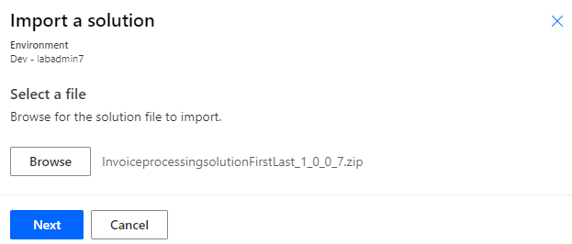

1. Select **Next** again.
2. Select **New connection** for the desktop flow.

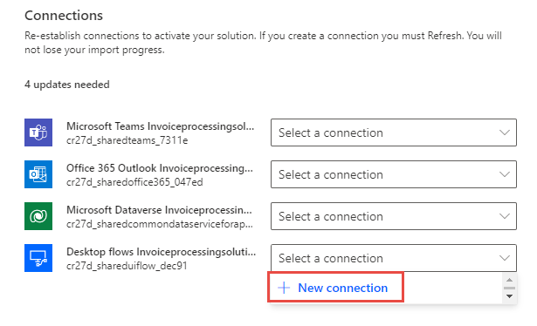

1. Select **Direct to machine**, select the machine you registered in the setup lab 1, provide your login information and then select **Create**.

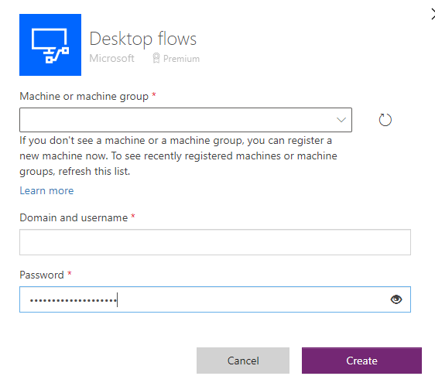

1. Close the connections browser window or tab.
2. Select **Refresh**.

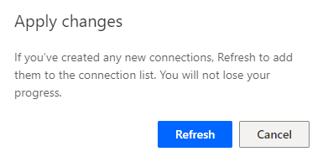

1. Select **New connection** for Office 365.

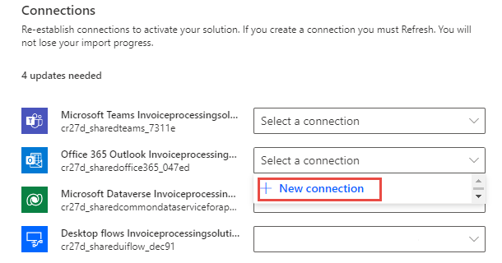

1. Select **Create**.
2. Provide your credentials.
3. Close the connections browser window or tab.
4. Select **Refresh**.
5. Select **New connection** for Microsoft Dataverse.
6. Select **Create**.
7. Provide your credentials.
8. Close the connections browser window or tab.
9. Select **Refresh**.
10. Select **New connection** for Microsoft Teams.
11. Select **Create**.
12. Provide your credentials.
13. Close the connections browser window or tab.
14. Select **Refresh**.
15. You should now have desktop flow, Office 365, Microsoft Dataverse, Microsoft Teams connections. Select **Import**

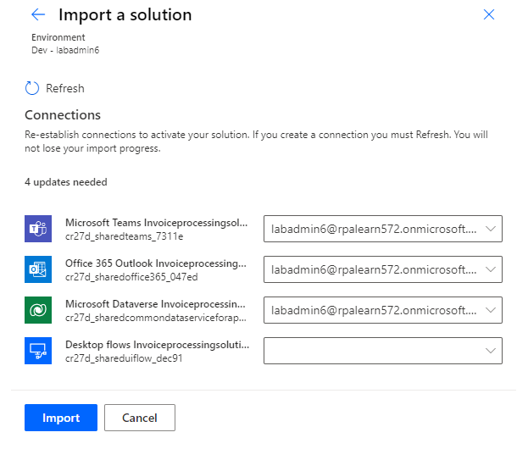

1. Wait for the solution to be imported.
2. Select Publish all customizations and wait for the publishing to complete.
3. Expand **AI Builder** and select **Models**.
4. Wait for the **Enter invoice information AI model** import to complete. When is done, the **Status** will change to **Published**.

1. Select **Solutions** and open the imported **Invoice processing solution**.

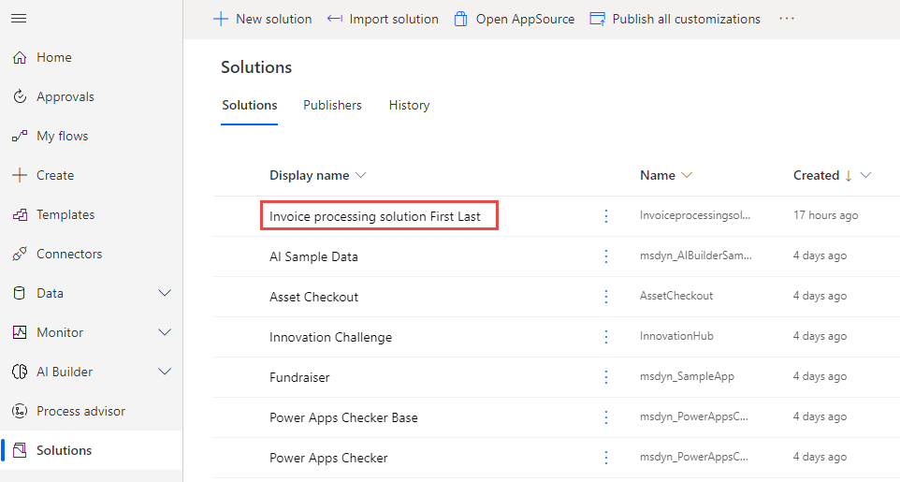

1. Select **Cloud flows** and open the **Enter invoice information flow**.

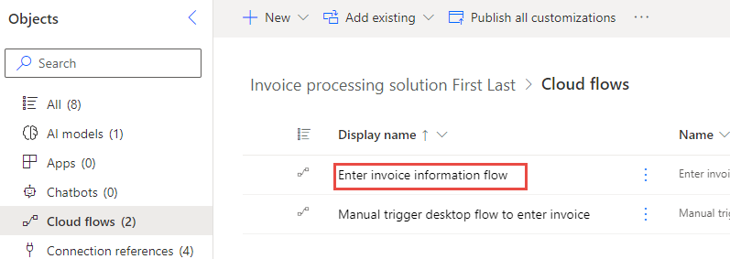

1. Select **Edit**.
2. Expand the **Apply to each** and the **Post a choice of options …** steps.
3. Change the **Recipient** email to your user’s email address.

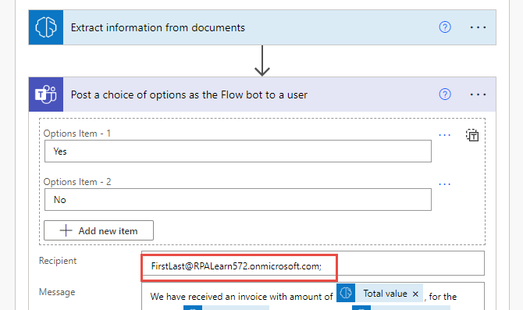

1. Select **Save** and wait for the flow to be saved.
2. Close the flow editor browser window or tab.
3. Open the **Enter an invoice** desktop flow.

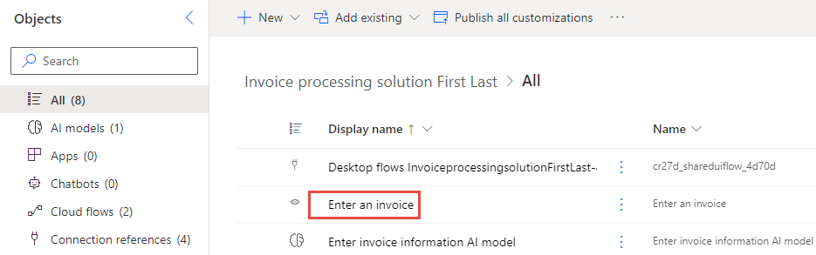

1. Select **Edit**.
2. Select **Launch app**.
3. Select **Open Power Automate**.

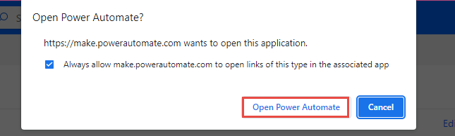

1. Sign into Power Automate if prompted.
2. Select the **Write_notes_into_excel subflow** tab.
3. Double click on the **Launch Excel** step.

1. Select the **Select file** button of the Document path.

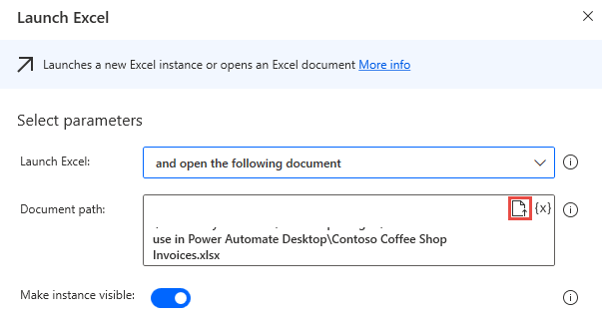

1. Locate and select the **Contoso Coffee Shop Invoices.xlsx** file located in the resources folder, and then select **Open**.
2. Select **Save**.

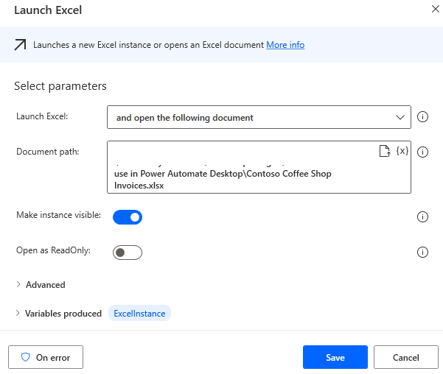

1. Save the flow and wait for the flow to be saved.
2. Close Power Automate desktop.